Practice One
PHRASE | NP |  | VP | ADVP | NP |  | PP
WORD | Our | horse | is | usually | a | darling | on | the | weekend
Part of Speech | Det | N | V | Adv | Det | N | Prep | Det | N

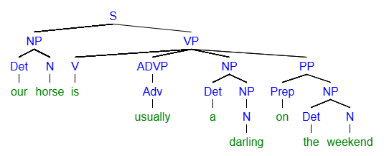
[S [NP [Det our] [N horse]] [VP [V is] [ADVP [Adv usually]] [NP [Det a] [NP [N darling]]] [PP [Prep on] [NP [Det the] [N weekend]

Practice Two
PHRASE | NP |  | ADVP | VP | ADJP
WORD | Some | folks | seldom | seem | truly | confident | in | their | partners
Part of Speech | Det | N | Adv | V | Adv | Adj | Prep | Det | N

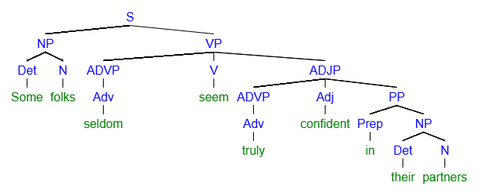
[S [NP [Det Some] [N folks]] [VP [ADVP [Adv seldom]] [V seem] [ADJP [ADVP [Adv truly]] [Adj confident] [PP [Prep in] [NP [Det their] [N partners]]

Practice Three
PHRASE | ADVP | NP | VP | NP | PP
Word | Frequently | astronauts | eat | food | in | space
Part of Speech | Adv | N | V | N | Prep | N

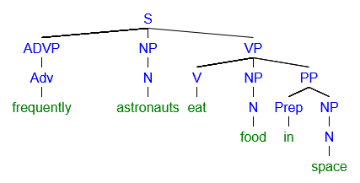
[S [ADVP [Adv frequently]] [NP [N astronauts]] [VP [V eat] [NP [N food]] [PP [Prep in] [NP [N space]]
Practice Four
PHRASE | NP |  | VP | PP |  | PP
WORD | That | guy | sits | at | home | on | the | weekends
Part of Speech | Det | N | V | PP | N | Prep | Det | N

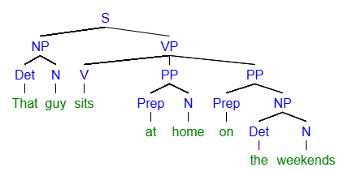
[S [NP [Det That] [N guy]] [VP [V sits] [PP [Prep at] [N home]] [PP [Prep on] [NP [Det the] [N weekends]]
Example Five
PHRASE | NP |  |  | VP | NP | NP
WORD | One | tiny | octopus | showed | me | things | about | life
Part of Speech | Det | Adj | N | V | Pro | N | Prep | N

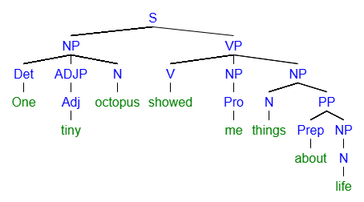
[S [NP [Det One] [ADJP [Adj tiny]] [N octopus]] [VP [V showed] [NP [Pro me]] [NP [N things] [PP [Prep about] [NP [N life]
Example Six:
PHRASE | NP |  | VP | NP | ADJP |  | PP
WORD | The | doctor | labeled | Janice | extremely | healthy | at | her | visit
Part of Speech | Det | N | V | N | Adv | Adj | Prep | Det | N

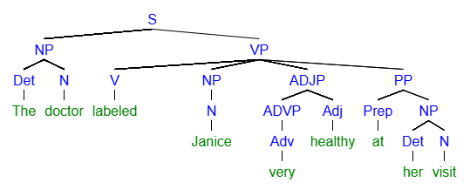
S [NP [Det The] [N doctor]] [VP [V labeled] [NP [N Janice]] [ADJP [ADVP [Adv very]] [Adj healthy]] [PP [Prep at] [NP [Det her] [N visit]

